**Burkina Faso country profile**

Published

5 March 2018

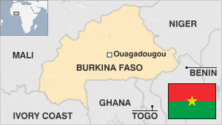

**A poor country even by West African standards, landlocked Burkina Faso has suffered from recurring droughts and military coups.**

Burkina Faso, which means "land of honest men", has significant reserves of gold, but the country has faced domestic and external concern over the state of its economy and human rights.

A former French colony, it gained independence as Upper Volta in 1960.

In 1983 Capt Thomas Sankara seized power and adopted radical left-wing policies but was ousted by Blaise Compaore, who went on to rule for 27 years before being ousted in a popular uprising in 2014.

* Read more [country profiles](http://news.bbc.co.uk/1/hi/country_profiles/) - Profiles by [BBC Monitoring](http://bbc.co.uk/monitoring)

**President: Roch Marc Kabore**

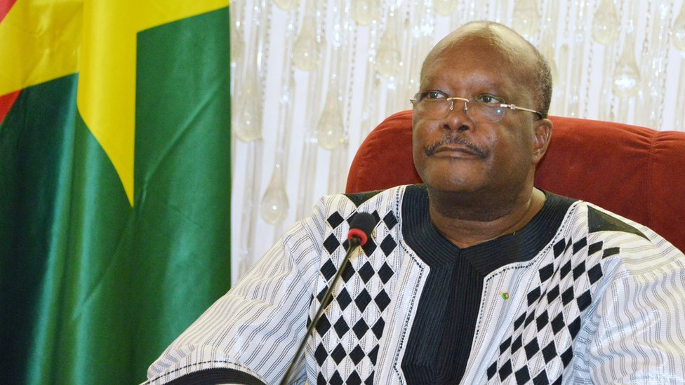image copyrightGetty Images

Marc Kabore, who served as prime minister and speaker of parliament under veteran President Blaise Compaore, won the November 2015 presidential election, easily beating his main rival.

The intervening year before Mr Kabore's election saw considerable turmoil, including an attempted coup by troops loyal to the ousted president in September 2015.

A French-educated banker, Mr Kabore sees himself as a social democrat, and has pledged to reduce youth unemployment, improve education and healthcare, and make health provision for children under six free of charge.

Kabore was a long-standing Compaore loyalist, but he quit as chairman of the then-president's Congress for Democracy and Progress party in 2014 over the head of state's plans to amend the constitution to extend his 27-year rule.

# Burkina Faso profile - Timeline

Published

5 March 2018

## A chronology of key events :

**1896 -** Kingdoms now making up Burkina Faso become a French protectorate.

**1919** - Upper Volta becomes separate constituent territory of French West Africa.

**1958** - Upper Volta becomes autonomous republic within the French Community.

## Independence

**1960** - Upper Volta becomes independent with Maurice Yameogo as president.

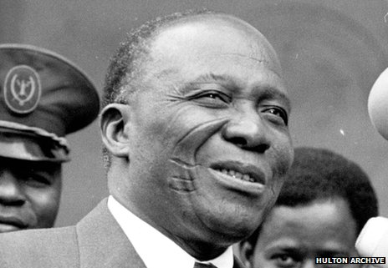image copyrightHulton Archive

image captionSangoule Lamizana came to power in a 1966 coup

**1966** - Yameogo toppled in a military coup led by Sangoule Lamizana following unrest over a government austerity programme.

**1970** - New constitution approved in a national referendum allows Lamizana to remain in power until 1975, when he was due to be replaced by an elected president; Gerard Ouedraogo appointed prime minister.

**1974** - President Lamizana re-asserts authority by ousting Prime Minister Ouedraogo and dissolving parliament.

**1977** - New multi-party constitution promulgated, allowing President Lamizana to remain in office. He wins 1978 presidential election.

## Coups

**1980** - President Lamizana is ousted in coup led by Saye Zerbo.

**1982** - Saye Zerbo is overthrown in a coup led by Jean-Baptiste Ouedraogo following industrial unrest.

**1983** - Capt Thomas Sankara takes power from Mr Ouedraogo in an internal power struggle. He adopts radical left-wing policies.

**1984** - Upper Volta renamed Burkina Faso.

**1987** - Thomas Sankara ousted and killed in a coup led by his close aide, Blaise Compaore.

**1990** - Compaore introduces limited democratic reforms.

**1991** - Compaore re-elected without opposition under a new constitution.

## Return to democracy

**1992** - Compaore's Organisation for Popular Democracy-Labour Movement wins a majority of seats in the first multi-party parliamentary elections since 1978.

**1998** - Compaore wins presidential election by a landslide.

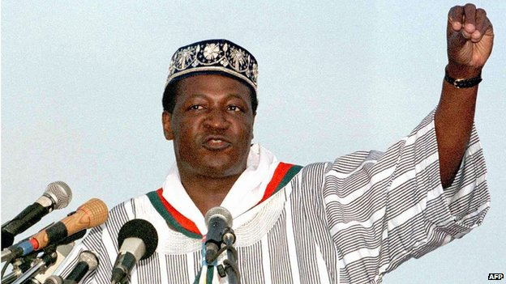image copyrightAFP

image captionPresident Compaore was in power for 27 years

**1999** June - General strike over economic grievances and alleged human rights violations.

**1999** August - State-owned mining company Soremib announces the closure of the country's biggest gold mine.

**2000** December - Government agrees to set up UN-run body to monitor weapons imports after allegations that it has been involved in smuggling arms to rebels in Sierra Leone and Angola.

**2004** April - Military tribunal tries 13 people accused of plotting coup against President Compaore in October 2003. Army captain Luther Ouali jailed for 10 years for masterminding plot.

**2005** November - President Compaore wins a third straight term in office.

**2006** December - Burkina Faso postpones a regional economic summit after deadly gun battles between police and soldiers in the capital.

**2007** May - The ruling party wins a majority in parliamentary polls.

**2008** April **-** Two-day general strike follows weeks of protests about high living costs and call for wage increases.

**2009** April - Parliament passes a law requiring at least 30% of candidates put forward for election by political parties to be women.

**2010** July - France, US issue travel warnings, citing the possibility of kidnappings by al-Qaeda operatives.

**2010** November - Gold mine officially opened. Premier Tertius Zongo says it will earn substantial revenue for the country.

Presidential elections. President Compaore gains another term in office.

## Unrest

**2011** March - Weeks of violent protests follow the death of a student in police custody.

**2011** April - Soldiers, presidential guards mutiny over unpaid allowances. Thousands of people protest over food prices.

**2011** July - Seven people are killed when government forces suppress mutiny in Burkina Faso's second city, Bobo Dioulasso.

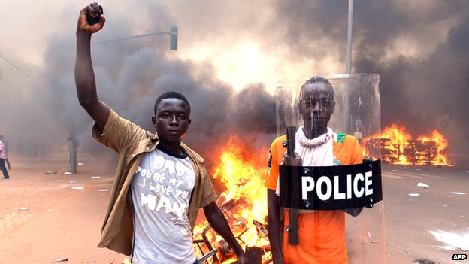image copyrightAFP

image captionMounting protests against plans to extend President Compaore's rule led to his ouster by the military

**2012** January - President Compaore sacks head of Burkina Faso's customs service, Ousmane Guiro, following the seizure of nearly $4m in two large suitcases traced by police to Mr Guiro.

**2012** November - President Compaore mediates talks to resolve the crisis in Mali, where Islamists have taken control of the north.

**2013** April - International Court of Justice in The Hague settles a decades-old border dispute between Niger and Burkina Faso.

**2013** July - Thousands of demonstrators take to the streets over plans to create a Senate. Opposition leaders say the move will allow President Compaore to extend his rule.

**2014** January - Demonstrators across the country oppose possible plans by President Compaore to prolong his rule.

Defectors from the ruling party found a new political movement to challenge the president.

**2014** October - More mass protests against proposed constitutional changes to allow the president another five years in power turn into a mass uprising that drives President Compaore from office.

Military takes charge in move condemned by opposition, civil society groups, United States and African Union.

**2014** November - Agreement reached on a framework for a transitional government to run the country until elections proposed for the end of next year. Political and military leaders choose former Foreign Minister Michel Kafando as interim president.

**2015** April - Romanian security officer at a mine in the north is kidnapped. Islamist militants later claim to be holding him.

Interim parliament bars politicians allied to deposed president Blaise Compaore from running in the presidential and general elections planned for later in the year year.

**2015** May - Work starts on exhuming what is believed to be the body of former leader Thomas Sankara ahead of DNA tests to determine the identity and cause of his death.

**2015** September - Acting President Kafando faces down coup attempt by presidential guard allies of Blaise Compaore.

**2015** November - Former prime minister Roch Marc Christian Kabore wins presidential election, comfortably beating former Economy and Finance Minister Zephirin Diabre.

**2016** January - Islamist militants attack a hotel and cafe in the capital, Ouagadougou, killing 29 people, many of them foreigners.

**2016** December - Islamists waving black flags storm a military base near the Mali border and kill 11 soldiers.

**2017** February - Five Sahel countries agree to set up a joint counter-terrorism force.

**2017** August - 18 people are killed in a terrorist attack on a Turkish restaurant in the capital Ougadougou.

**2018** March - French embassy comes under attack. Sixteen people are killed, including eight gunmen.